**Tier 1**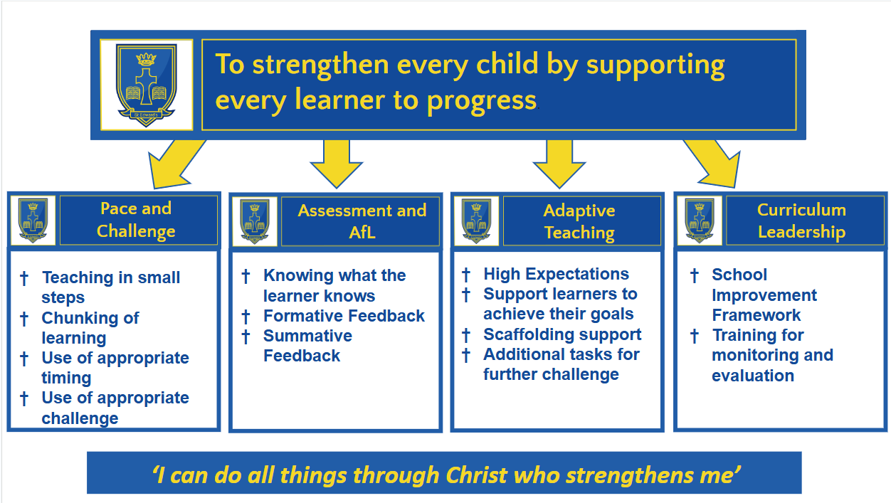

**Tier 2 Collective efficacy and Adaptive teaching Leadership Togetherness Mission**

| Aim | **Quality of Education**  Quality of teaching and learning and adaptive teaching in all classrooms enables all pupils to make at least expected progress. | **Self Evaluation and monitoring**  To Increase the capacity of subject leads to self assess and improve the quality of teaching and learning in their subjects. | **Working more closely with St Joseph’s Catholic Infant School on the journey towards Federation**  To work more closely with St Joseph’s | **Catholic Life**  Develop pupils’ understanding of Catholic Social Teaching to enable them to articulate how it impacts on their daily lives and how it has led to action. |
| --- | --- | --- | --- | --- |
| Intent | By adapting lessons and using modelling, explanations and scaffolds, teachers ensure that all pupils have the opportunity to experience success whilst maintaining high expectations for all. | Train subject leaders in curriculum development to ensure quality of curriculum intent and implementation is assured. | To create a joint mission for both school communities. | To provide quality CPD to enable all staff to develop their own understanding of Catholic Social Teaching and to use effective pedagogy to communicate this to pupils. |
| To further embed the Behaviour Curriculum routines and link this to direct instruction with a focus on appropriate pace. | To develop a consistent monitoring programme which enables all leaders to robustly challenge teaching and learning within their subject. | To align curriculum and curriculum leadership so that the education experience of all pupils is consistent and enhanced. All staff across both schools work together closely to align systems and practices. | To provide opportunities for pupils to demonstrate how faith calls them to love God and love our neighbours in every situation. |
|  |  | To develop consistency in teaching and behaviour expectations across both schools. | To nurture in pupils inspiration to initiate and carry out ‘Faith in Action’ ideas of their own.  To use this to provide feedback to pupils and drive improvement |
| Implementation |  |  |  |  |
| By end of Advent 2 | Quality of Teaching and Learning is at least Good in all classes with a focus on direct instruction, pace and challenge.  Trust Literacy Lead to deliver CPD on modelling. | CSED will be completed.  Monitoring for Subject leaders will be streamlined. It will be clear what is expected from subject leaders and by when. | Joint mission statement will have been agreed. | Create visual resources to explain and inform the meanings of Catholic Social Teaching so that it is visible to all. |
| By end of Lent 2 | Consistency across all classes in marking, AfL feedback and pupil response.  New initiatives which include Literacy leaves, daily mental Maths sessions and embedding oracy techniques are used to engage pupils and improve the quality of education. | CPD will be provided to support in areas where it is required.  Visits to other schools will take place in order to see best practice. | Curriculum leaders will work together to develop a joint curriculum.  Subject leaders will have met together from across both schools and action plans agreed | Pupils can discuss the 9 key principles which sum up CST. They can remember some and draw links between these principles and actions they have taken and would like to take. |
| By end of Pentecost 1 | Further CPD on adaptive teaching  Scaffolding is evident in planning and teaching. | A fully embedded monitoring programme is robust. Targeted improvements have occurred at pace and can be evidenced.  Monitoring is accurate and used effectively to develop. | All stakeholders will have a more united experience of both schools. | Mini Vinnies, Faith Committee and Mission Team work together to lead events and assemblies with Catholic Social Teaching Focus.  Terms relating to Catholic Social Teaching are widely used and understood across the school. |
| Impact | KPIs  Pupil Voice, Parent Survey and monitoring, assessments, learning walks, lesson drop-ins | KPIs  Subject leader meetings with SLT, pupil voice, book looks, external validation | KPIs  Staff surveys, pupil voice, monitoring, parent survey | KPIs  Pupil Voice, Parent Survey and monitoring |

**Tier 3**

| Aim | **English: Reading**  To develop a culture of reading for pleasure, increasing pupils’ engagement with reading. | **Maths**  To focus on developing fluency so pupils can calculate and solve problems more efficiently. | **Community Engagement**  To engage parents, carers and the wider community in the life of the school. | **RE**  To implement the new RED curriculum | **Mental Health and Wellbeing**  To continue to improve pupil and staff wellbeing  To build on the open culture of discussing mental health and wellbeing. |
| --- | --- | --- | --- | --- | --- |
| Intent | To use Literacy Tree Literary Leaves planning as the core structure for reading lessons. | To increase pupils’ fluency in mental maths | To offer opportunities for families to share in prayer and liturgies within school. | To develop teachers’ knowledge and understanding of new RED curriculum. | To ensure policies are written to show current strengths of school and include future direction. |
| To integrate oracy techniques within reading lessons to increase pupil engagement. | To embed the use of manipulatives for all pupils within maths lessons. | To identify ways of reinvigorating parental voice through a Family Forum in order to gather parents and carers views and ways of acting upon them. | RE lessons are planned in an engaging way and pupils learn. | To identify ways of listening to pupil and staff voices and acting upon them |
| To develop a book rich environment that inspires pupils, using the DfE Reading Framework recommendations. | To develop staff knowledge, skills and confidence in the teaching of arithmetic and reasoning | To build staff links with FOSE in order to identify and create new fundraising and social opportunities for the school community. | To develop staff understanding and use of assessment and progress in RE using the new RE Directory. | To include mental health and wellbeing provisions within the current SEN Provision Map software. |
| Implementation |  |  |  |  |  |
| By end of Advent 2 | Literary Leaves are being used daily  Oracy techniques are evident in lesson  Reading Ambassadors have been chosen | Daily mental maths sessions are timetabled and taught  Resources have been audited and purchased in order to facilitate teaching the daily mental maths session  CPD on bar modelling has been booked and attended | New staff link member has attended FOSE meetings.  Parent/Carer questionnaire has been sent out to identify preferred times and format for Family Forum meeting.  Family forum meeting held.  Advent liturgies open to parents  International Evening held | Relevant staff have attended identified CPD sessions in RE | Mental Health and Wellbeing policies for pupils and staff are written and agreed by governors.  PASS survey has been completed by all pupils and data analysed.  Daily pupil check-in has been introduced.  Data from July 2024 staff survey has been analysed and actions agreed. |
| By end of Lent 2 | Termly author visits to school are embedded  Book libraries, of high quality, well chosen texts, are evident in every classroom.  Outdoor library installed and used by pupils. | Manipulatives have been audited.  CPD on use of manipulatives have been booked and attended  Lesson observations show manipulatives used and evidence of mental calculations being used. | Parents/carers invited to Stations of the Cross  Parents/carers have access to quiet prayer time in school Prayer Room during Lent  Family Forum held | Year 6 has implemented RE Directory and is using the new curriculum to plan and teach RE lessons. | Mental Health and Wellbeing area of school website has been implemented in order to signpost available resources to families. |
| By end of Pentecost 1 | A comprehensive book list has been identified and a reading spine created | Assessment data shows increase in achievement in maths | Parents/Carers have had opportunities to support activities in school and to attend any events led by their children.  Family Forum held and actions from previous Family Forums have been addressed. | RE lessons are effective and Planning and Book scrutinies are used effectively to identify track progression of learning, skills and knowledge in Year 6. | Mental Health provisions have been added to ProvisionMap software and support plans embedded.  2nd PASS survey completed by pupils and data analysed.  Staff survey completed to measure impact of staff wellbeing policy and progress of actions. |
| Impact | KPIs  Pupil Voice, Parent Survey and monitoring, learning walks | KPIs  Pupil Voice, Parent Survey and monitoring, learning walks, assessment data | KPIs  Pupil Voice, Parent Survey and monitoring | KPIs Pupil Voice and monitoring | KPIs  Pupil Voice, Parent Survey and monitoring, staff survey |