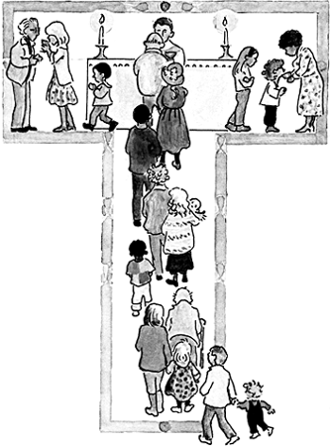

**St Edwards Catholic Junior School**

**Lent Term 202**5

**God the SAVIOUR~ DIGNITY~ INCARNATION~ Who am I?**

| **TOPIC ~ THEME** | **ABOUT THE TOPIC** | **STARTING DATES** | **Special Feasts** |
| --- | --- | --- | --- |
| Church  Local Church: Community | Year 3: Journeys  Year 4: Community  Year 5: Mission  Year 6: Branch 3 RED Galilee to Jerusalem | 6th January –  31st January | 6th January; Epiphany of the Lord 9th January- New Year Mass in school at 9.30am  14th January - Presentation in the Temple (Candlemas) Y3 |
| Sacrament  Eucharist: Relating | Year 3: Listening & Sharing  Year 4: Giving & Receiving  Year 5: Memorial Sacrifice  Year 6: 2 weeks to finish Branch 3/ 2 Weeks to begin Branch 4 | 3rd February -  7th March  (17th February-  21st February- Half term) | 11th February: Our Lady of Lourdes  1st March: St David patron of Wales  5th March Ash Wednesday |
| Christian Living  Lent/ Easter: Giving | Year 3: Giving all  Year 4: Self-Discipline  Year 5: Sacrifice  Year 6: Branch 4 RED Desert to Garden | 10th March –  4th April | 17th March- St Patrick, patron of Ireland  19th March- St Joseph  w/b 31st March: Stations of the Cross  Palm Sunday: 13th April  Holy Week: 14th April- 20th April |